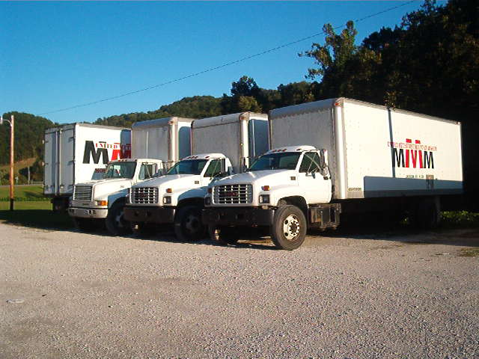 **Methodist Mountain Mission**

**UPDATE ON TRUCK FINANCIAL NEED**

We praise the Lord for answering our need for more trucks!

And for the very generous people who gave to our truck fund.

Our original urgent needs request stated that we had borrowed $16,600

from our local bank on a note due September 9, 2017

to purchase a smaller truck.

In addition, we had located a larger truck to add to our fleet.

The cost of it was $29,250.

With your help, we were able to pay these two trucks off.

As of July 24, 2017, we have received $45,402 in truck donations.

The Lord has provided another large truck and

we have stepped out on faith to purchase it.

The cost of this truck is $28,500 and we will be picking it up in a day or two.

$28,500! Can you continue to help us with this financial need?

It never, never ceases to amaze me at how generous you are, and I thank you in advance.

**For our Stores/Customers**

**\* Back-to-School clothes and**

**shoes**

**\* School supplies**

**\* Halloween costumes**

**PROCESSING PLANT NEEDS**

* Coffee and Creamer

* Vacuum cleaners for stores

* Tall kitchen bags - LOTS!

We use these to help fill bale trucks

* Paper Towels

* 33 gallon garbage bags

* Toilet Paper

* S-M-L Latex Gloves

* Febreeze Air Freshener

* Rubber bands

* Safety pins

And, of course, all of the other wonderful good and usable items you donate to the Mission!

Blessings,

Karen Bunn

**Urgent Needs List**